

FOOD GENDA

ADMINISTRATIVE PORTAL

“THE PROJECT MODULE REPORT”



SUBMITTED TO:

Dr Zubair Ahmed Shaikh

Ma’am Muntaha Mahboob

Ma’am Mahnoor Iftikhar

|  |  |  |
| --- | --- | --- |
| GROUP MEMBERS DETAILS | | |
| S. NO | **STUDENT NAME** | **STUDENT ID** |
| 02 | **MUHAMMAD MUBBASHIR SHAKEEL** | **SP20-BSCS-0084** |
|  |
|  |

Table of Contents

1. Introduction 1
   1. Purpose 1
   2. Product Scope 1
2. Overall Description 1
   1. Product Perspective 1
   2. Operation Environment 2 3

3

1. Deliverable 3

# INTRODUCTION

## Purpose

FoodGenda is a simple service to order food from a variety of restaurants or from a home supplier online the think which is different in this app is that not only from restaurant you can also enjoy homemade food. Housewife can cook food and can sell it. So, you can Enjoy different flavors delivered to your door step Even Any One can easily sale own food without any problem. The purpose of administration portal is that he/she Design attractive menus, develop a relationship with regular customers, follow food and safety regulations, ensure that customers are satisfied with food and service, assist with marketing events, create policies, hire new staff and new restaurants, look into all the matters, manage payments and see reviews and also reply them.

## Product Scope

In today’s world, almost all kinds of businesses have started opening shops online. So, it is only a matter of time before food was sold online. The revenue got by selling food online is going to increase in every major country. In every project administration portal is must because in every project there has to be someone who look into all the matter. Who can manage all things? Admin have to solve all the problem so that clients will be satisfy. In today world review is everything so Admin see all the review and act according to it for better approach.

# OPERATING ENVIRONMENT:

* **Tools**
* **Front Hand:**

We operate the software in react native & visual studio code.

* **Back Hand:**

Database in which store data of patient into back-end. Core php is used to back-end connectivity.

* **Language**

## We use JavaScript

# OVERALL DESCRIPTION

## Admin module

1. Add new restaurants
2. Manage payment methods
3. Manage customer profiles
4. Customer reviews

* **NEVIGATION BAR:**

He NEVIGATION is side pop up bar through we can access the sub modules

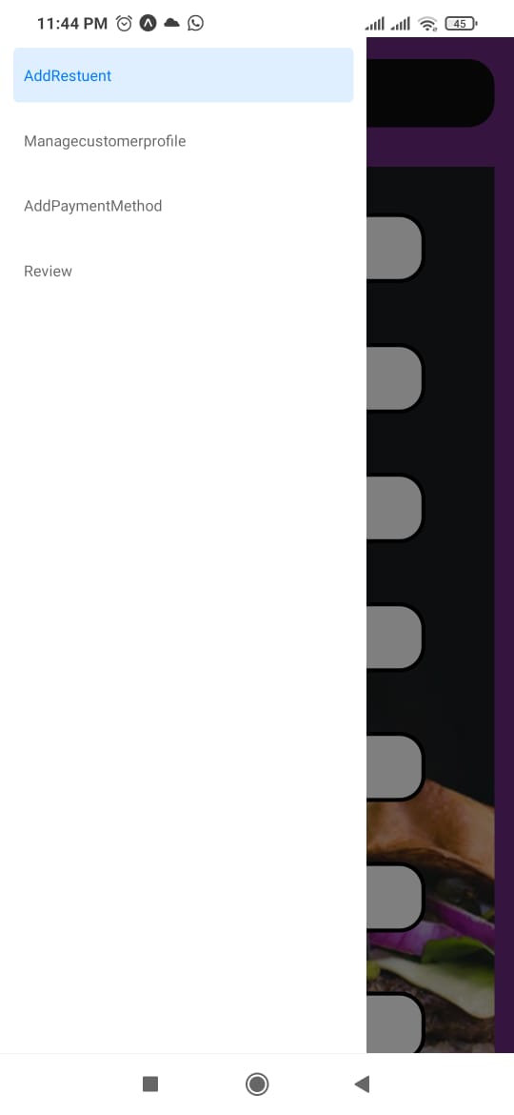

* **ADD NEW RESTAURANT:**

If commercial or non commercial customer want to add so this is for them they have to give these information which store in data base and then they will able to supply their foods to the peoples. In this we also do validation like for example: you cannot enter cnic number more then 14 digits.

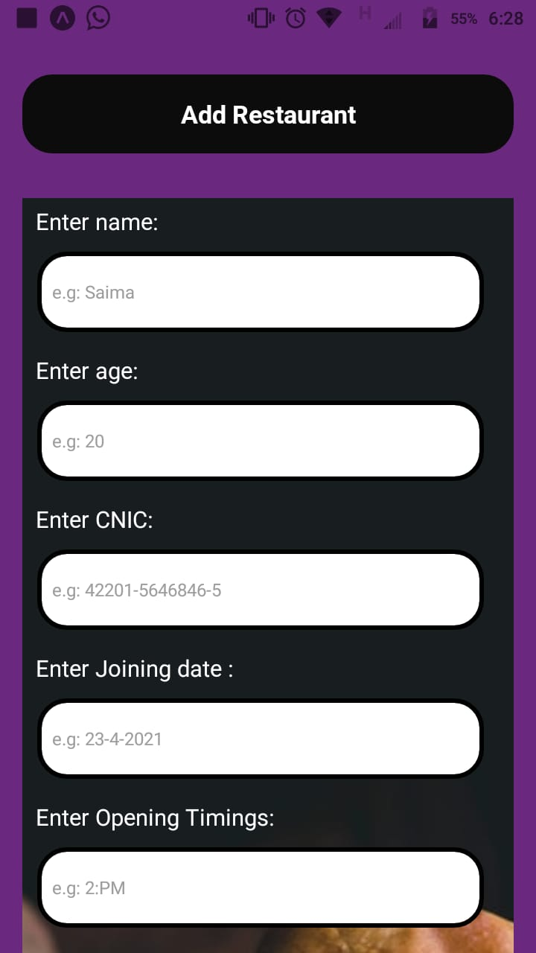

* **MANANGE CUSTOMER PROFILE:**

In manage customer we have to manage the customer profile and the history of the customers so that we have the record of the customer in this we also did validation and the customer have to provide these information our task is just to manage customer profile so we just made dummy in this

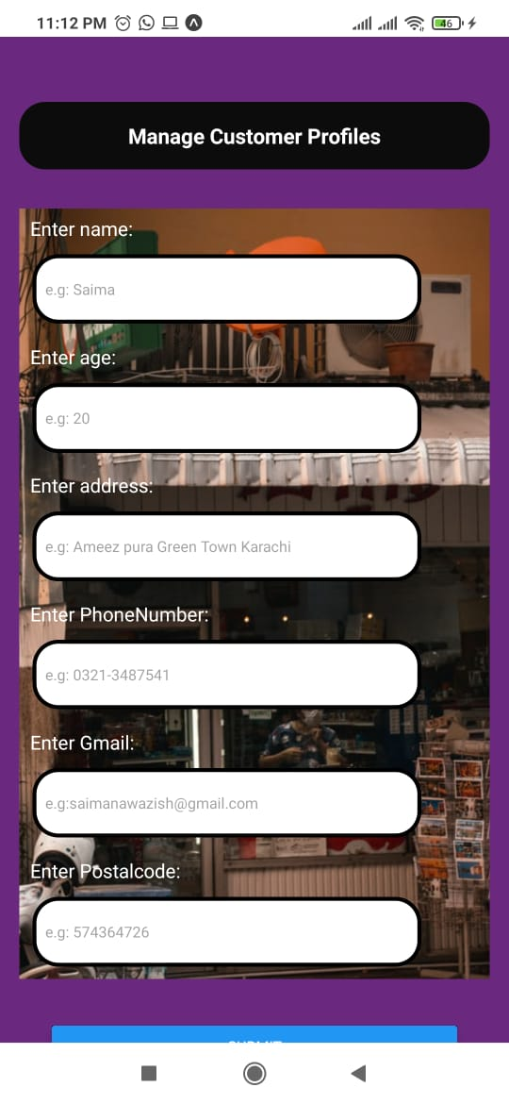

* **MANAGE PAYMENT METHOD:**

In this we we have to manage the history of customer payment so we just made a dummy as our teachers says but its not our work we just made a dummy. The payment history of customer come from data base.

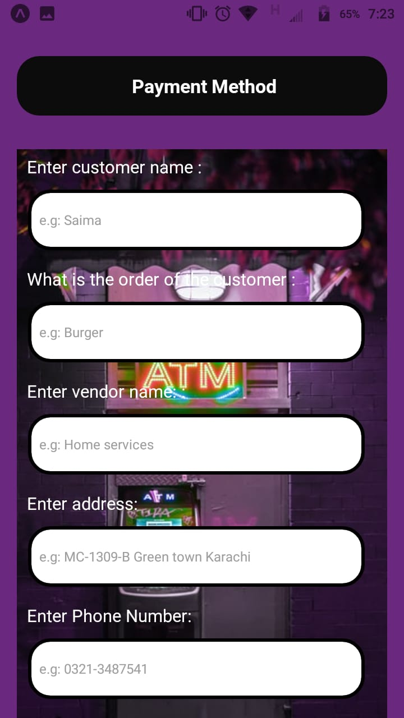

* **CUSTOMER REVIEWS:**

In this customer have to give reviews and some advices so we have to look up for it and answer on them we also made dummy for this.

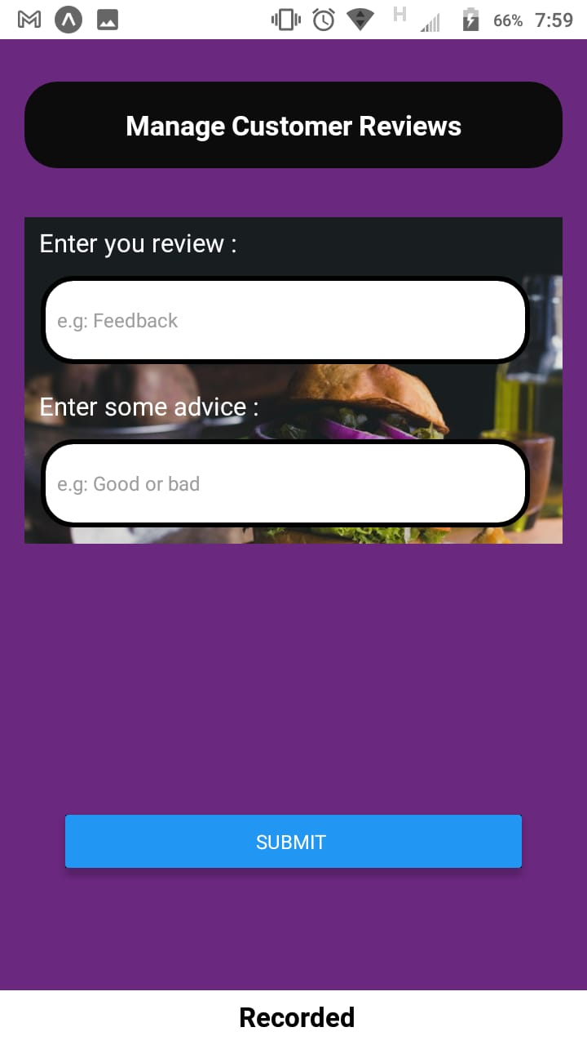

# 4. MAIN GOAL

Our main goal is to built a successful fast food mobile App Create a sense of loyalty to the customer to make them regular customers, and make customer completely satisfied. And develop the software for not only commercial but also non commercial

# 5. DELIVERABLES

|  |  |  |
| --- | --- | --- |
| ID | NAME | WORK |
| SP20- BSCS-0073 | MALIKA ZEHRA | REPORT & SOME WORK IN SOME MODULE |
| SP20-BSCS-0051 | SAIMA NAWAZISH | ADD RESTURENT,ADD PAYMENT METHOD,REVIEWS |
| SP20-BSCS-0070 | ZAIN ALI KHAN | CSS ALL MODULES |
| SP20-BSCS-0084 | MUHAMMAD MUBBASHIR | DATABASE |